CHRSTINE RABACAL
ENGLISH
GRAE 7, D BLOCK
“MY BEST FRIEND”

My cousin is my best friend, we were born a month apart. She is funny and smart, a little crazy, but overall very friendly, we always have lots of fun together. We have always done everything together and people often get the two of us mixed up. Most people, if they see us going together somewhere, will ask us, “Are you two sisters?” we’ll simultaneously reply, “Cousins, but people always think we’re sisters,” Our friends say that we look alike, which, I think, might true to a stranger, but, once you know us you can see the difference (and that we don’t look that alike). We have barely gone two weeks without talking to each other, let alone two months. My best friends name means ‘Dream’, her name is Ashlyn.

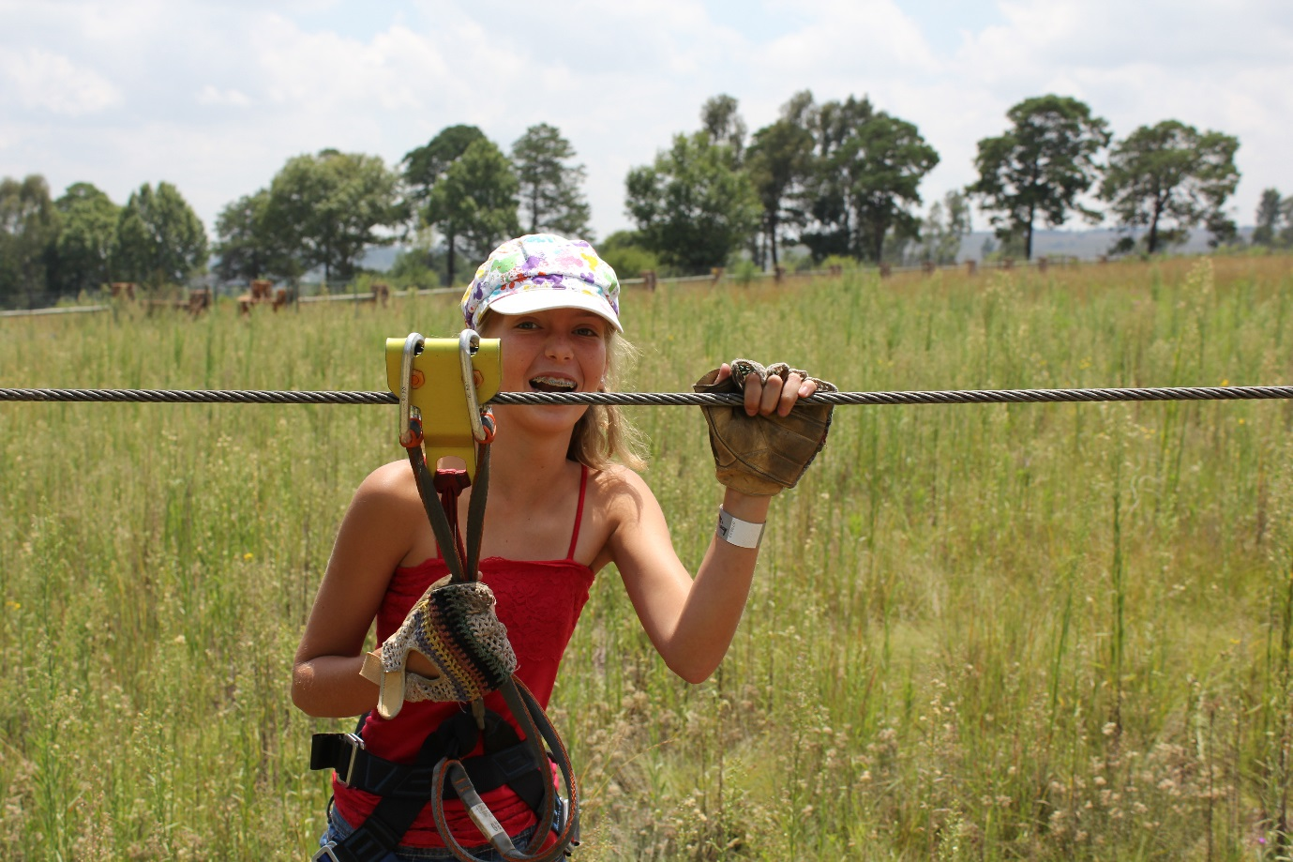
MY BEST FRIEND, ASHLYN

Ashlyn-11 yrs. old, Acro-Branch (Blue Curse), February 2013

